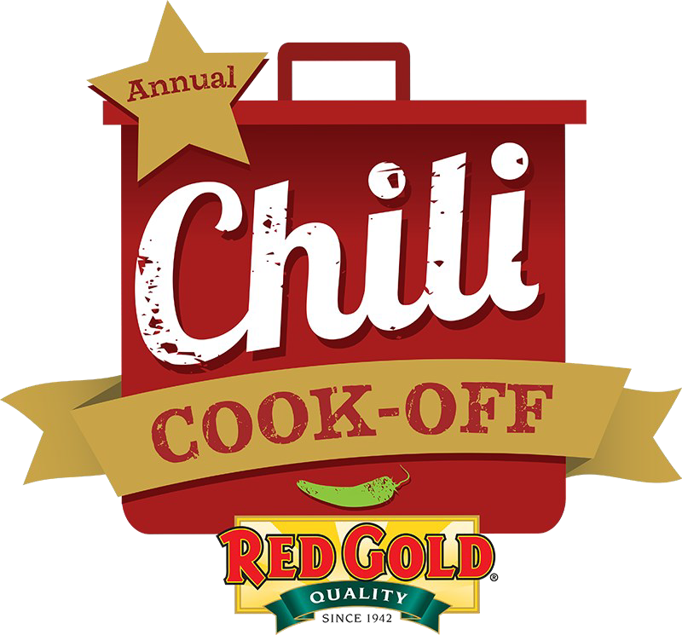
38th Annual Red Gold Chili Cook-Off

Saturday, October 10th
7am – 1pm | Serving at 10:30am
Elwood City Building
Anderson and South B Streets

So, you think you have the best chili? Throw your ladle in the ring and get ready to compete! Red Gold invites you to test your favorite chili recipe against some of the best in the 38th Annual Chili Cook-Off on Saturday, October 10th, 2026.
Proceeds from the Chili Cook-Off will benefit the Elwood Chamber of Commerce.

* Chili tasting * Indiana Beer & Wine Garden * Indianapolis Colts *
* Craft Booths * & More! *

 Chili booth Craft booth
Application deadline: Friday, September 25
Booth Entry: $35

Team / Booth Name: _____________________________________________________________________
Contact Person: Phone: _________________________________
Address, City, Zip: _
Email Address:
Chili Booth Applicants: ONLY 1 CHILI SAMPLE PER TEAM WILL BE JUDGED!
Name of Chili:
Heat Level (Please Circle): Mild Medium Hot
Chili Description: __
Vegetarian Chili (check is applicable):

Craft/ Non-Chili Booth Applicants: Please provide a description of the items to be sold at your booth (No flea-market type booths are allowed) _______________________________________________
BEVERAGE SALES OF ANY KIND ARE PROHIBITED

APPLICATION DEADLINE IS SEPT 25 AT 4PM. MAIL THIS APPLICATION AND CHECK MADE PAYABLE TO ELWOOD CHAMBER OF COMMERCE—Cindy Tyner, 108 S. ANDERSON ST., ELWOOD, IN 46036.

Rules & Regulations
Booth space for all entrants is $35 for a 10’ x 10’ space. Booths will be in the Elwood City Building Parking Lot. Electricity is not available, and there are no provisions for inclement weather. Chili Booth set-up time is 7:00 – 7:45 AM with a mandatory team captain’s meeting at 8:00 AM for Cook-Off entrants. Craft/Non-Cooking booths will not be checked in until 7:30 AM. All booths should be open by 8:30 AM.
*It is recommended that you bring a bee catcher to place near/inside your booth.
All entrants must bring their own set-up including tables and chairs. Red Gold will provide up to 100 cans of tomato and bean products free of charge. All cook-off entrants must use the Red Gold tomato products listed below (use of competing tomato products is prohibited). All entrants are required to make a minimum of 10 gallons of chili but are welcome to make more. All entrants must submit final recipe. Recipes may only be used one time. Recipes used in previous years will not be eligible to win.
The following items will be available from Red Gold for your Chili Recipe:
Please enter the number of cans of each product you wish to use for your chili recipe.
Items below will be available for pick up the day of the event. (Max 100 cans)
____ Diced Tomatoes 14.5 oz ____ Petite Diced Tomatoes 14.5 oz
____ Crushed Tomatoes 15 oz ____ Petite Diced Tomatoes w/Green Chilies 14.5 oz
____ Tomato Paste 6 oz ____ Chili Beans 15.5 oz
____ Tomato Juice 46 oz ____ Tomato Sauce 15 oz
____ Vegetable Juice 46 oz

Chili Cook-Off Awards & Rules
1st Place: $300 & Trophy // 2nd Place: $200 & Trophy //
3rd Place: $100 & Trophy // Best Decorated Booth: $50 //

The following rules are to be adhered to by all cooks and their assistants!
- Set-up begins at 7:00 AM. All team captains are required to attend the Captain’s Meeting at 8:00 AM at the Elwood City
Building Lobby for final instructions. Red Gold products will be distributed after the meeting.
- All entrants will be responsible for supplying all their own set-up including cooking utensils, tables, cook stove (gas grills), and all ingredients (except for the free Red Gold products).
- The cooking period will begin immediately following the Captain’s meeting and will continue until 10:30 AM. Each team must cook a minimum of ten (10) gallons of chili but are welcome to make more.
- Ingredients (such as ground beef or meat) MAY be precooked prior to the preparation/cooking period. However, chili must be assembled and prepared on-site, NO EXCEPTIONS.
- One team member will bring their Judge’s sample in an unmarked bowl with lid (provided) to the Elwood Municipal Building for judging by 10:25 AM. Late arrivals will not be accepted.
- Once released by the Chamber (10:30 AM), entrants may start to distribute their chili to the public.
- A supply of bowls, spoons, and a plastic tub for ticket collecting, will be given to each entrant. Collect 1 ticket for each bowl. Do not refill bowls. All unused bowls and your collected tickets will be picked up after the event and an audit will be conducted.
- All team captains must be 18 years or older, although assistants may be younger.
- The top 3 winners will receive cash prizes and agree to have their photograph printed for media.
- Chili will be judged on: Aroma, Texture, Color, and Taste/After Taste.
- The decision of the judges is FINAL, and sponsors reserve the right to deny participation and make rule amendments as needed.
- By entering, all prepared chili becomes the property of the Elwood Chamber of Commerce for sale to the public.

Chili-Cooking Entry Participants
I have read the Red Gold Chili Cook-Off Rules and Regulations listed above. I hereby agree to abide by all rules stated herein and any additional rules given the day of the event.
Signature: Date:
Questions or concerns? Email: ElwoodChamberManager@gmail.com

